*Fitness Data Analysis and Tableau Dashboard Supplementary XIAOLU LI*

1. Introduction

*Definitions*:

Considering that battery life is a pain point for users, and panels of different materials have different effects on product battery life. This stage aims to help the decision-making of panel and battery life of different types of products by analyzing the relationship between panel selection and battery life of different types of products.

*Implementation*:

Data analysis using python. Use Tableau to present data.

*Data sources:* Fitness Track Products E-commerce:

<https://www.kaggle.com/datasets/devsubhash/fitness-trackers-products-ecommerce>

2. Python

This dashboard is designed to analyze the relationship between product details of different brands and their popularity. Showcase details for each brand by correlating the brand's Price, Device type, and Battery life with user ratings.

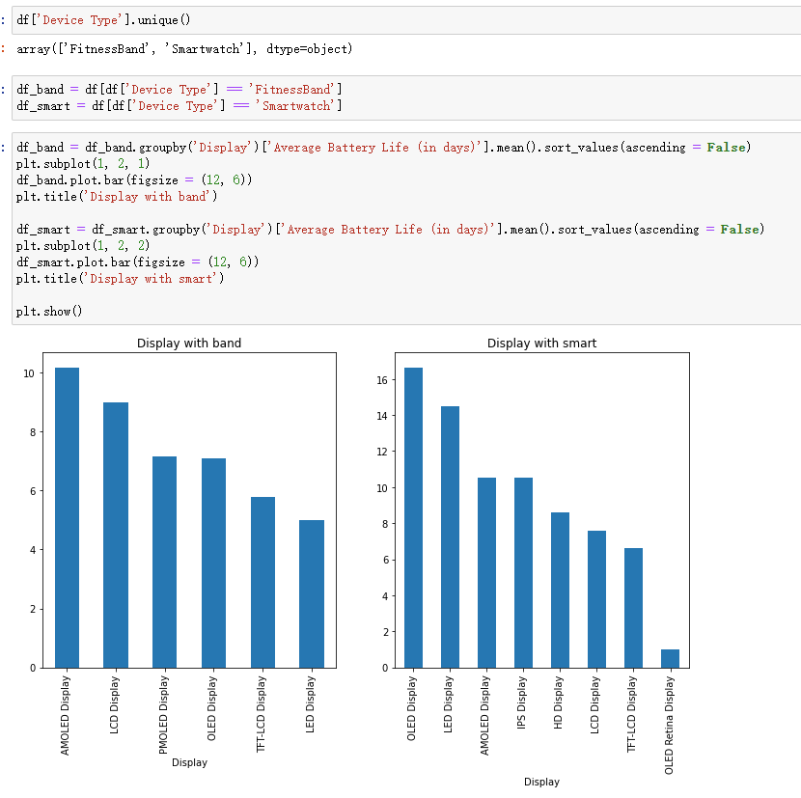

3. Dashboard

Dashboard:

<https://public.tableau.com/views/fitness_trackers_dashboard_addition/Fitness_trackers_battery?:language=zh-CN&:display_count=n&:origin=viz_share_link>

Dashboard

The battery life of different displays for each type of product could be shown interactively.

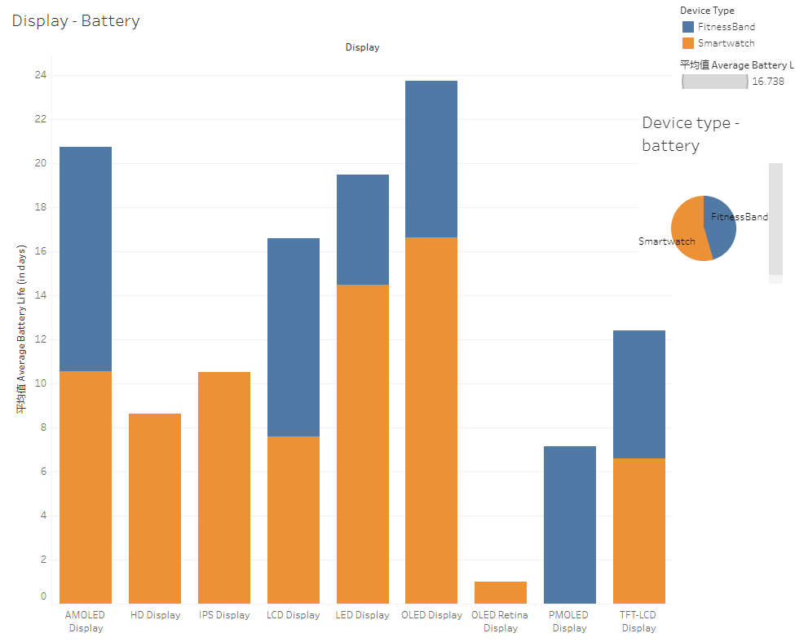

1st Graph

Average battery life for both types of products

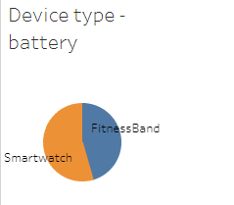

2nd Graph

The two types of devices differ in battery life for different display types.

